Joining points to areal units: a quick update

Jon Minton

14/10/2014

# The aim

To have mean pollution values, for a range of air pollutants, for Scottish datazones.

# Further details

The estimated pollution values, calculated by DEFRA, are presented for a grid of points spaced 1km apart. The eastings and westings for each point are known.

The ESRI shapefile for the 2001 census datazones contain each of the zone codes used in Scotland. For each zone code, the shapefile contains other data which defines the areal unit. This data comprises a series of coordinates which define the polygon of the areal unit.

The challenge  
The overall challenge is to have credible pollution values, for a range of pollutants, associated with each areal unit (2001 datazones).

The first challenge was to calculate which areal unit, if any, each point resides within.

# Process

A dataset comprising the following variables was constructed:

* x: easting
* y: northing
* ukgridcode: a unique identifier for each position

The ESRI shapefile for the 2001 datazones was found from the Edina data service based in Edinburgh. Within this shapefile, each datazone was defined by a unique value using the variable zonecode. These zonecodes all begin with S01, followed by a six digit number.

The open source GIS software QGIS was used. (My license for ARCGIS expired in August.)

Within QGIS, the shapefile layer appears as follows:

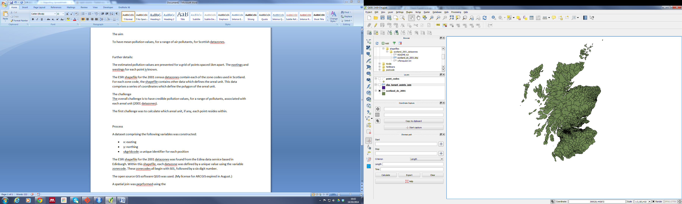

Figure ESRI 2001 Datazone shapefiles, loaded into QGIS

On the same scale, the point values appear as follows:

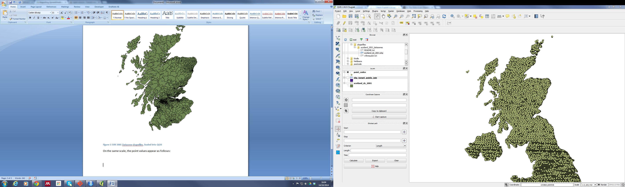

Figure 1x1km pollution points, loaded into QGIS

The irregular appearance of these points is an artefact of how the points are rendered at this scale. Zooming in shows the points to have a regular, lattice-like arrangement, as expected.

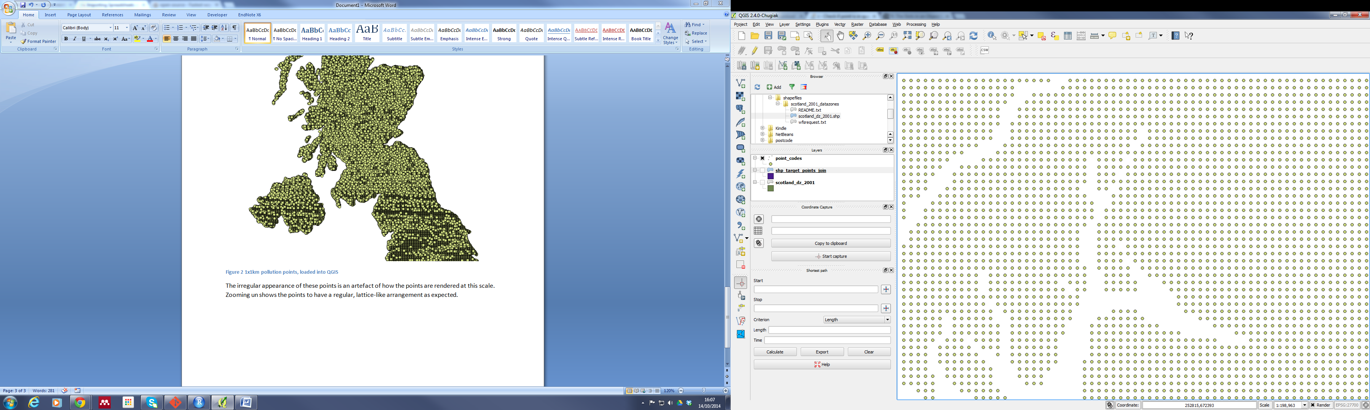

Figure The pollution data point coordinates, rendered at a higher spatial resolution

Overlaying the points on top of the areal units shows that some areal units contain multiple points, whereas others contain a single point, or no spatial points.

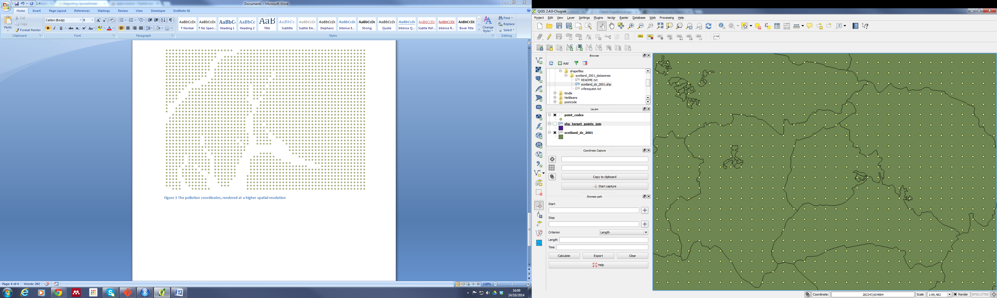

Figure Pollution estimate points overlaid on 2001 datazones

By using the ‘Spatial Join’ feature of QGIS, specifying the points as the ‘join’ layer, and the datazones as the ‘target’ layer, it was possible to associate many, but not all of the datazones with at least one point. This created an additional shapefile layer. In the image below, this additional shapefile layer is coloured purple. The additional layer is shown on top of the initial datazone layer, so any green sections indicate that the areal units have not been joined.

Initially, the spatial join appeared to be successful:

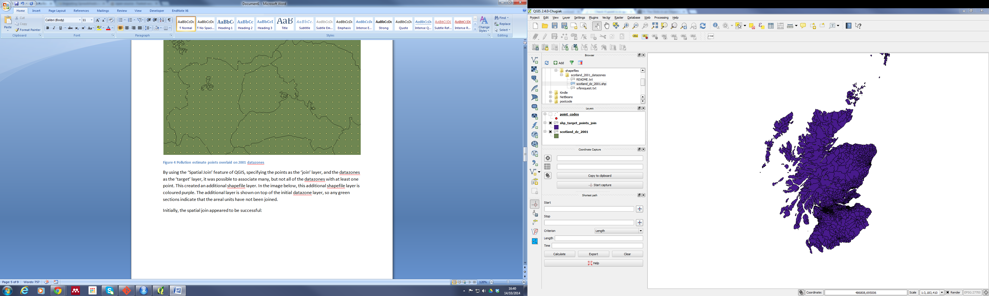

Figure Merged (purple) and non-merged (green) 2001 datazones

However, at a higher spatial scale the extent and patterning of the non-merged areal units becomes apparent:

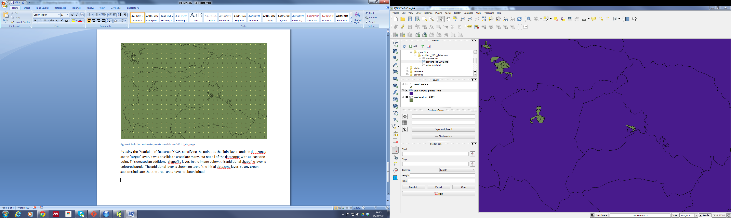

Figure Merged areal unit (purple) overlaid on 2001 shapefiles (green).

Of course, the more populated an area, the smaller the areal unit, and the smaller the areal unit, the less likely it is to contain at least one point, and so to merge.

As would be expected, within the cities of Glasgow and Edinburgh, which contain a large number of small but nearby areal units, the pattern of non-merged areal units tends to have a checkerboard pattern, with one matched unit often surrounded by a number of non-matched unit

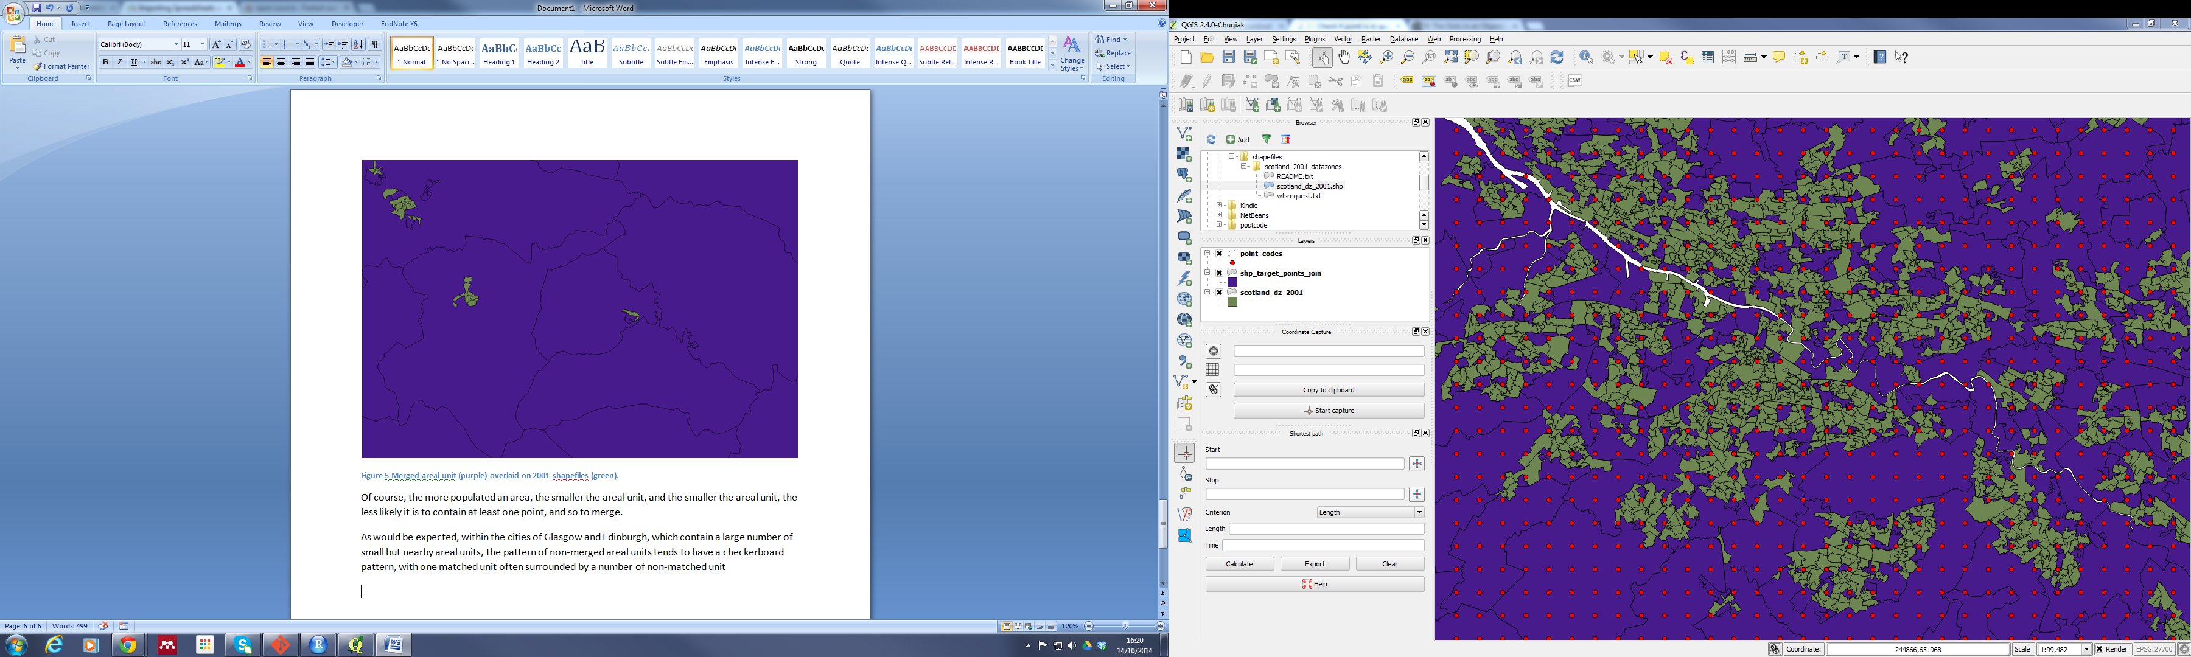

Figure 7 Matched and unmatched areal units near Glasgow. The bottom layer (green) is the shapefile layer. The middle layer (purple) is the matched areal unit layer. The top layer (red), shows the point coordinates.

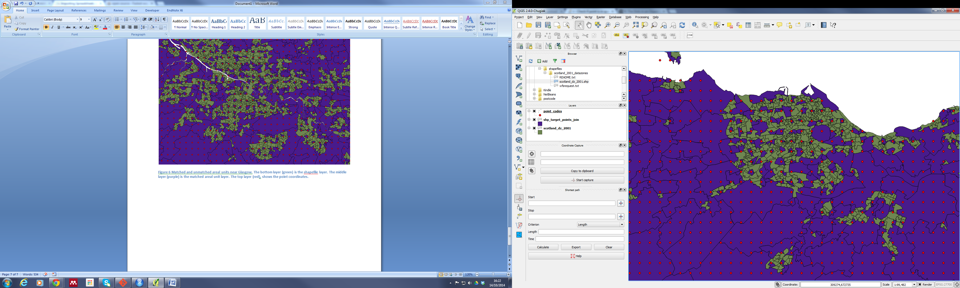

Figure As in the previous figure, but for Edinburgh

At a higher spatial resolution, the problem is clearer still:

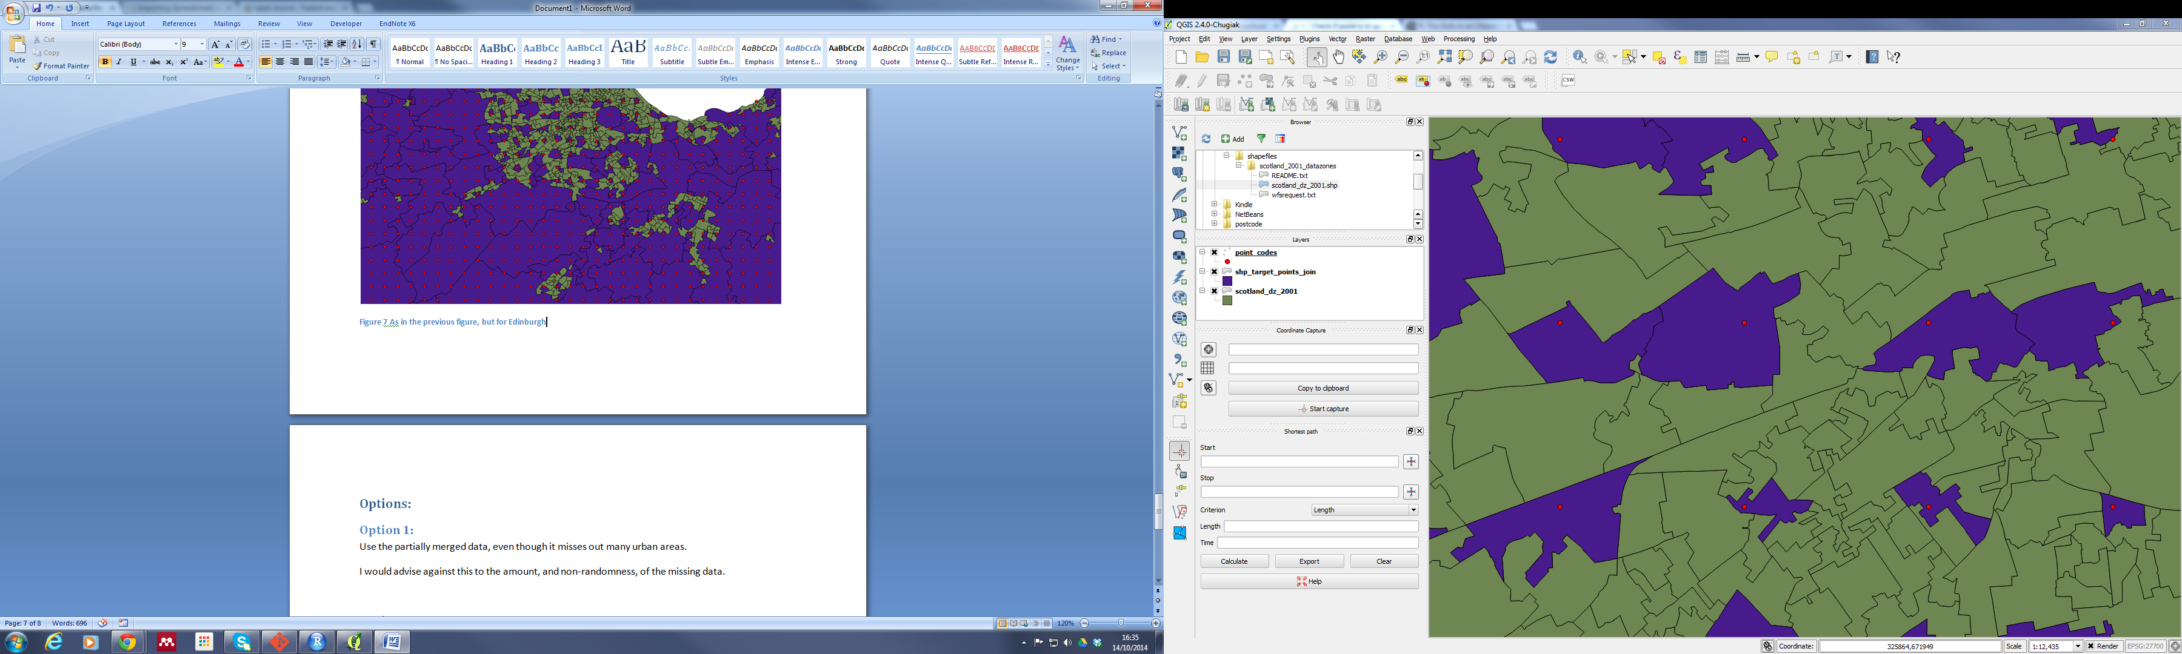

Figure As before, but at a higher spatial resolution

# Conclusion

The 1x1km resolution of the points is too coarse to match many or most urban areal units. Alternative approaches which get around this issue are required.

# Options

## Option 1:

*Use the partially merged data, even though it misses out many urban areas.*

I would advise against this to the amount, and non-randomness, of the missing data.

## Option 2:

*Use intermediate geographies*

This may be worth trying, at least as a short term solution.

## Option 3:

*Impute missing cells from (say) mean of contiguous areas.*

I think the amount of missingness suggests this will lead to a lot of cells that are effectively populated by guesses of guesses of guesses, and so are not likely to be reliable

## Option 4:

*Use the values at the coordinates to impute continuous pollution surfaces for each of the pollutants, and calculate the integral of the pollution surfaces inside each of the areal units.*

This is likely to be the most conceptually elegant solution, but also likely to be one of the most difficult.

**Suggested next option to try: option 2.**